Revision
27 Feb 2018
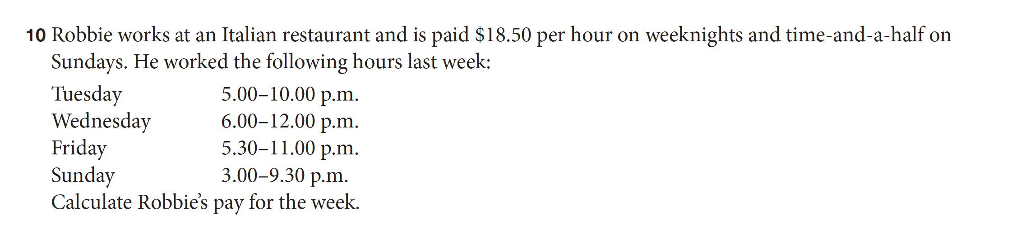
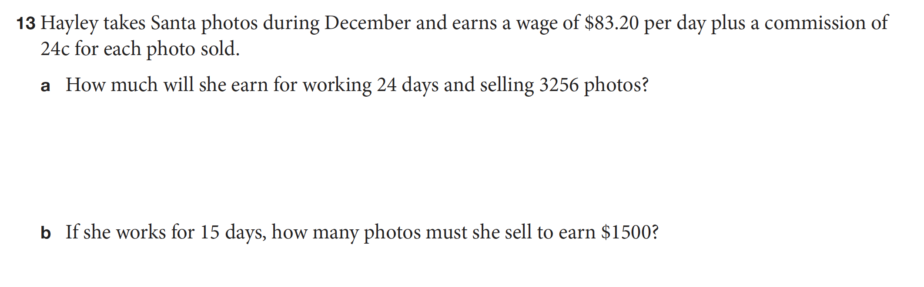

Revision
27 Feb 2018



